Changes in GIS

Affected modules: Contract Open, Contract Changes, Contract Check In, Contract Adjustment, Foreign Check In, Sales Accessory, Reservation, Customer.

To ensure that GIS is PCI (Payment Card Industry)-compliant and to further protect cardholder data, all stored credit card numbers will only display the first and last four digits, as shown in Figure 1.

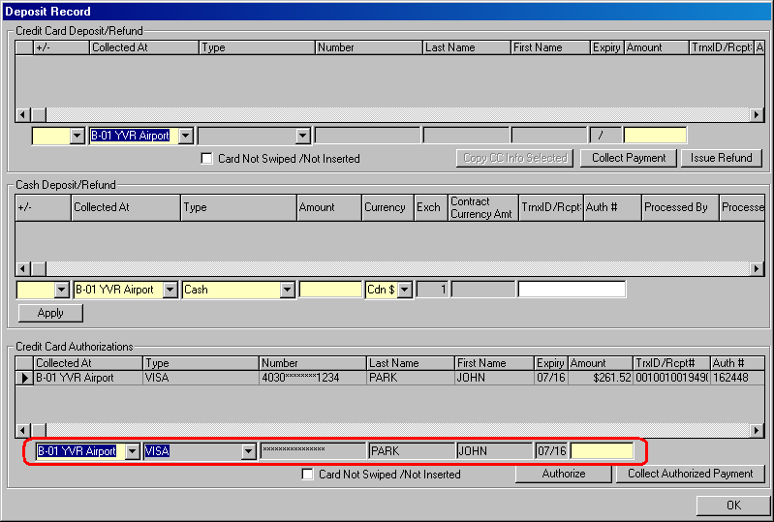
Figure 1: Notice that the credit card information is now masked.

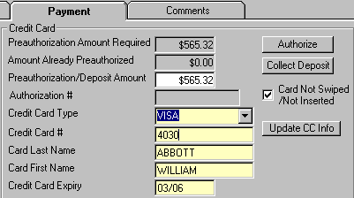
The credit card number is masked only when the credit card has already been processed or saved on GIS. As you enter the credit card number, however, the number will be displayed (See Figure 2).

Figure 2: Credit card number is not masked upon data entry.

If there is a record in the Credit Card Deposit/Refund section in the Deposit/Refund Record screen, notice that the Copy CC Info Selected button is enabled. To collect another payment or to do a refund, you must first select the record which contains the credit card you want to process on, as shown in Figure 3. Selecting the first record is essentially the same as selecting the VISA card. Selecting the second record however means you are choosing the AMEX card.

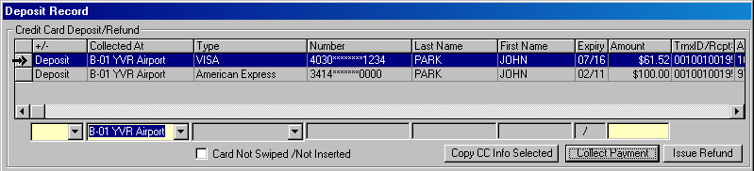
Figure 3: Select the record from the grid before you click the Copy CC Info Selected button.

After the record is selected, click on the Copy CC Info Selected button to copy down the credit card information into the empty fields (See Figure 4). Then you can proceed to select the transaction type and enter the transaction amount. Recall that if your work station is not connected to a PINpad, you must select the Card Not Swiped/Not Inserted box before carrying out the payment or refund transaction.

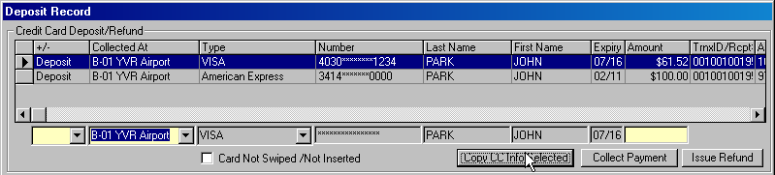
Figure 4: The Copy CC Info Selected button copies the selected credit card data into the fields below.

